SOFTWARE DEVEOPLMENT APPROACH

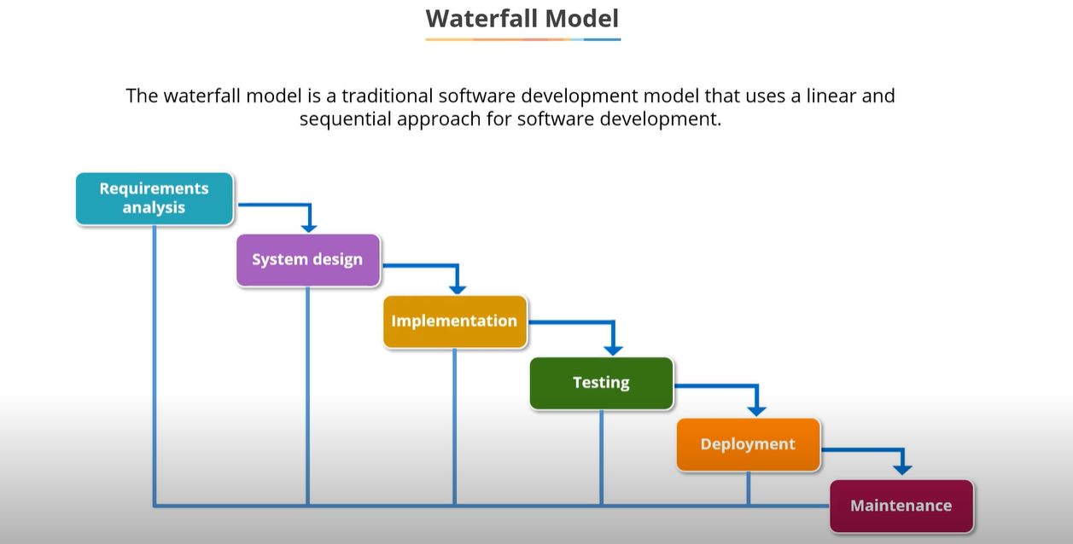

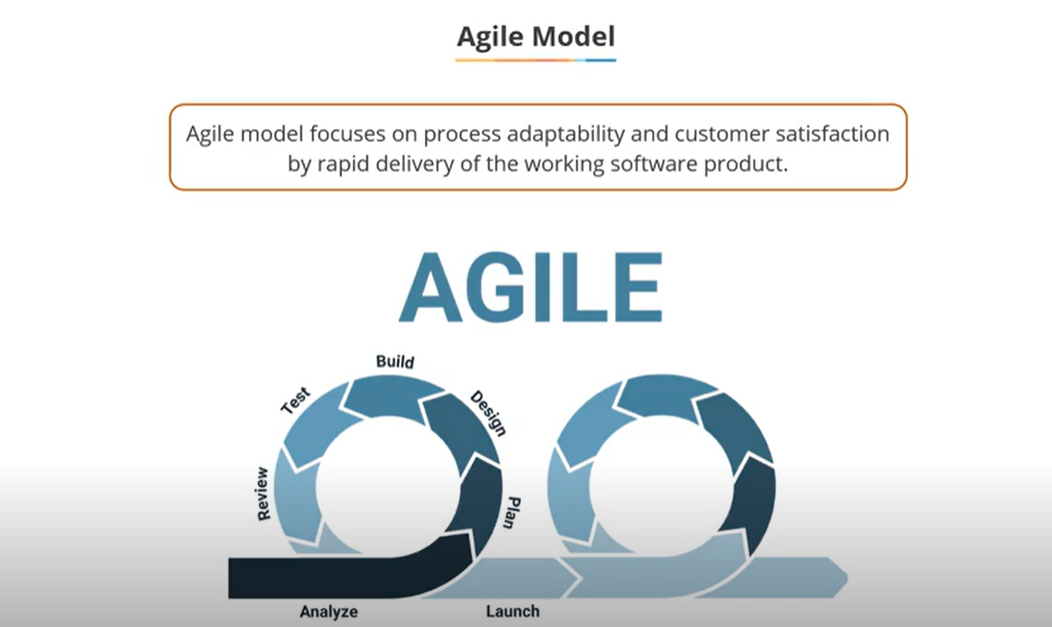

DEVOPS: - Devolvement and operation activates

It is the combination of automation tool which help you to speed up the process delivery of software to clients.

Relationship between Agile and Devops

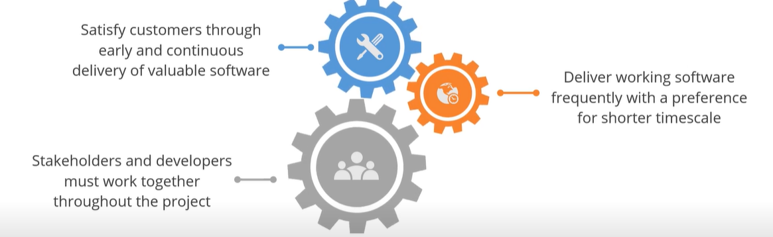

The benefits of using Agile with Devops are :

* Replace non-human steps using automation tools
* Improve collaboration between the teams
* Automate to create a potentially shippable increment of the code

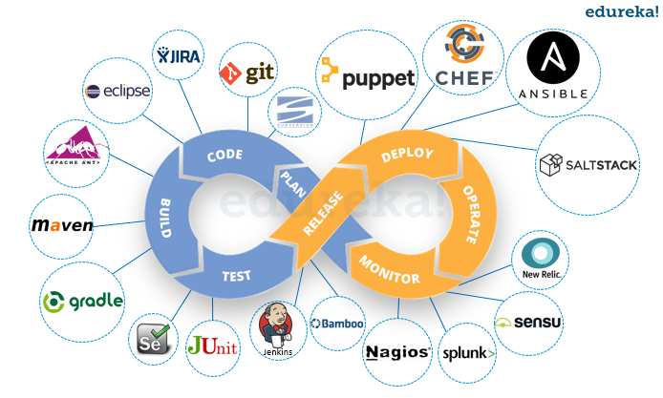

JENKINS:

Jenkins executes a series of actions to achieve the continuous integration process and continuous delivery of software projects.

Jenkins has very rich plugin library and global community support.

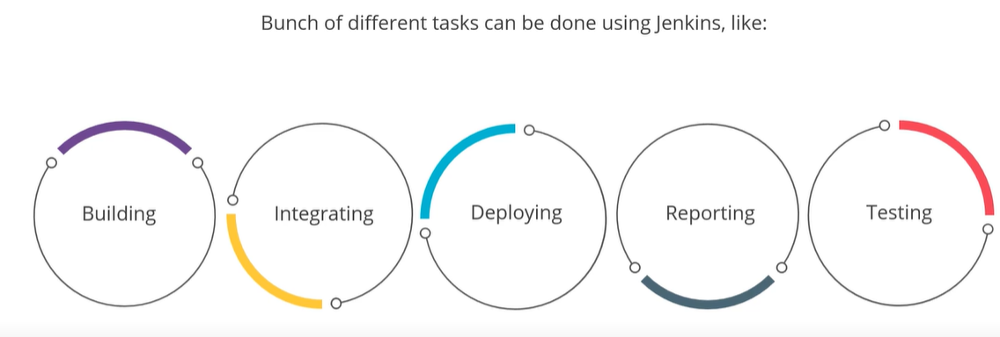

There are five stages in Devops lifecycle

Continuous Integration

=============================

Stage 1 (Continuous Download)

==============================

Developers create some code and upload it into some version

controlling system like Git. Jenkins should immediately download

that code and this is called continuous download

Stage 2 Continuous Build

=============================

The code downloaded in the previous stage has to covered into a

setup file commonly know as artifact. This artifcat can be in the format

of jar, war, ear file etc. To trigger this build process Jenkins uses

build tools like Maven, Grade, MS build etc. This stage is called continuous

build

Stage 3 (Continuous Deployment)

==================================

The artifact in the previous stage has to deployed into the testing

environment. This testing servers might be running on some application

servers like tomcat, WebLogic etc. Once it is deployed here it become

available to the testers. This is called continuous deployment

Stage 4 (Continuous Testing)

================================

Testers create automation test scripts using tools like Selenium, **Cucumber, TestNG** etc. Jenkins now executes these automation testing scripts and check if the application is working correctly or no. If it not working Jenkins will send

email notifications to the corresponding team members. Developers will

fix the defects and upload the modified code into git, Jenkins will again

start from stage 1

Stage 5 (Continuous delivery)

=============================

If testing passes Jenkins will deploy that artifact into the production

servers form where the end user or client can start accessing it

This is called continuous delivery

Stage1-4 are called as CI (Continuous Integration)

Stage 5 is called as CD (Continuous Delivery)

Setup of servers for CI-CD

=====================================

1 Create AWS ubuntu instances

and name them Jenkins server

Installing Jenkins

==========================

1 Connect to Jenkins server using Git bash

2 Update the apt repository

sudo apt-get update

3 Install java

sudo apt-get install -y openjdk-11-jdk

4 Install git and maven

sudo apt-get install -y git maven

You can see the below commands from link <https://www.jenkins.io/doc/book/installing/linux/#debianubuntu>

5 Download Jenkins-key

curl -fsSL https://pkg.jenkins.io/debian-stable/jenkins.io.key | sudo tee \

/usr/share/keyrings/jenkins-keyring.asc > /dev/null

6.Download Jenkins-repository

echo deb [signed-by=/usr/share/keyrings/jenkins-keyring.asc] \

https://pkg.jenkins.io/debian-stable binary/ | sudo tee \

/etc/apt/sources.list.d/jenkins.list > /dev/null

7.Update the apt repository

Sudo apt-get update

8. Install the Jenkins

sudo apt-get install jenkins -y

9 To access jenkins from browser

public_ip_of_jenkinsserver:8080

10 Unlock jenkins by entering the first admin password

go to location you will find password

sudo cat /var/lib/jenkins/secrets/initialAdminPassword

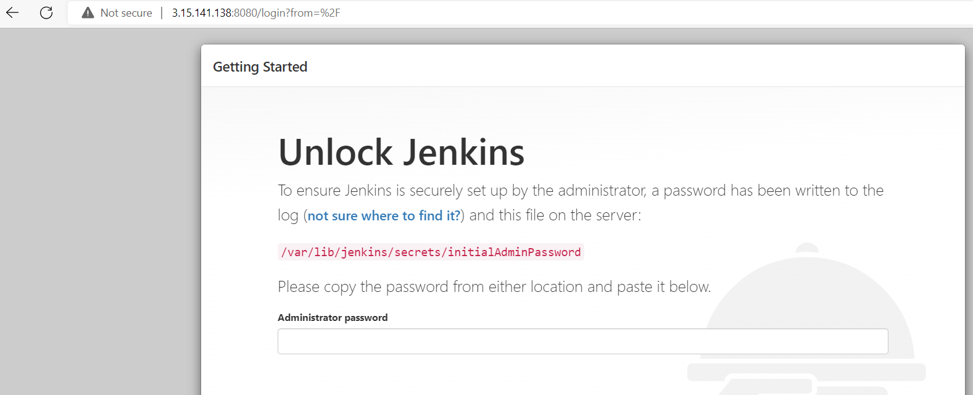

11 Click on the Install suggested plugins

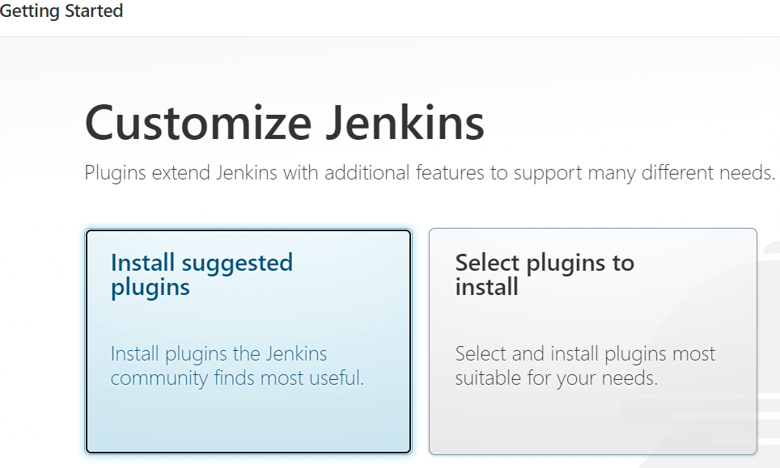

12 Create first admin user

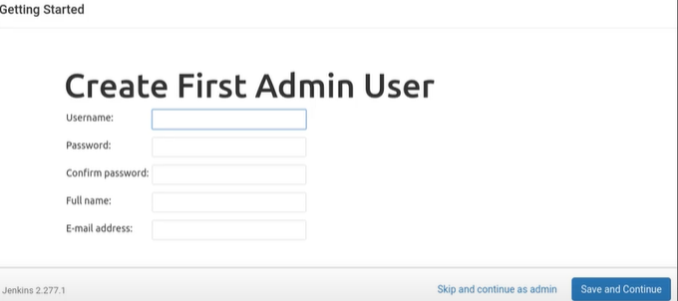

13 Click on Continue--->Finish

We will see the jenkins dashboard





